Black Swan Pub Takeaway Menu
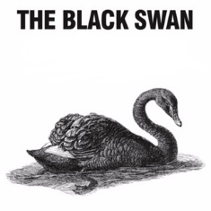
Tomato and Mozzarella Salad (v) £6.95
Salt and Pepper Chicken £6.95
Dragon Chicken with Wasabi Mayo £6.95
Southern Fried Chicken Strips £6.95

Fish N Chips with mushy peas £8.95

12 Inch Pizza:
Margarita (v) £8.25
Loaded veggie (v) £9.50
Pepperoni £9.75
Ham and Mushroom £9.95
Garlic Bread with Cheese £5.25

Sides
Basket of chips or skinny fries £3.25
Fried Rice £3.95
Coleslaw Sm. £1.95 Lg. £3.75

Available Thursday thru Saturday 5-8pm Pick up by reserved time slots
01423-871031

Takeaway Wine

WHITE

Senorio de Chical Verdejo(house) £14.95
Bosco Pinot Grigio £16.50
La Pintora Sauvignon Blanc £16.50
Cape Spring Chenin Blanc £16.95
Southway Chardonnay £18.95
Paterson Grove Sauvignon Blanc £20.95

RED
Senorio de Chical Tempranillo (house) £14.95
Cantina Della Torres Sangiovese Puglia £15.50
La Pintora Merlot £16.50
Southway Shiraz-Sagrantino £16.75
Bodegas Rasillo Tinto Rioja £17.50
Morita Malbec £20.95

ROSE
Bosco Pinot Grigio Rose (VERY PALE PINK) £16.25

SPARKLING
Vino Spumante Prosecco £21.95

Available Thursday thru Saturday 5-8pm Pick up by reserved time slots
01423-871031

